Principles and Applications in Systems Biology

Exercises 1

In this exercise we have usedecoli_core_model.mat as our model and we have used ibm_cplex as our solver.

Part 1:Simulating growth. Comparing the growth yield among alternative substrates in aerobic and anaerobic conditions.

1. Find the objective function. Find the biomass reaction. Define the biomass reaction as the objective function. model = changeObjective(model,'Biomass_rxn’);

Our goal in this question is to optimize the objective function, the biomass reaction in the present case. In our program, we have expressed the biomass function as *Biomass_Ecoli_core_N(w/GAM)-Nmet2*.

1. Find the exchange reactions. Find the glucose exchange. Define the glucose exchange to be -10 mmol/gDW/h. Check that the uptakes of the other substrates in the list are blocked. model = changeRxnBounds(model,'EX_glc(e)',-10.0,'l')

The code for this question can be found in the Matlab script. The exchange reactions can be found in the “rxns” field of the model.

1. Find the maximal growth yield for glucose. This is an introduction to the FBA problem: understand the inputs required for the FBA problem and the outputs of it. FBAsolution = optimizeCbModel(model,'max');

As we our model shows, the maximal growth rate in glucose is 1.6531 hr-1. The inputs required for the FBA are the model that we want to work on and the reaction that we want to optimize. The output of the FBA is a structure (FBAsolution) containing the value of the objective function after optimization (FBAsolution.f), the distribution vector of the fluxes in the different pathways (FBAsolution.x), the vector of the corresponding shadow prices (FBAsolution.y) and the vector of reduced costs (FBAsolution.w). The model also allows us to constrain the organism by adding aerobic or anaerobic conditions, controlling the amount of carbon source used, or addition of similar conditions.

1. Create a script to (i) define one-by-one the alternative substrates as the only carbon sources, (ii) calculate the maximal growth yield for each of them. Consider for each carbon source an uptake rate of 10 mmol/gDW/h. Perform the simulations in aerobic conditions: oxygen uptake rate of 20 mmol/gDW/h.

The answer to this question is provided in our Matlab code for Part 1.

1. Repeat step 4 for anaerobic conditions.

The answer to this question, similar to question 4, is provided in our Matleb code.

1. Visualize an optimal solution for aerobic and anaerobic growth on 10 mmmol/gDW/h glucose in an ESCHER map and describe the changes in the flux profile qualitatively.

In the following ESCHER map (Figure 1) , you can see the initial state of the metabolic pathway of E.coli when there are no fluxes.

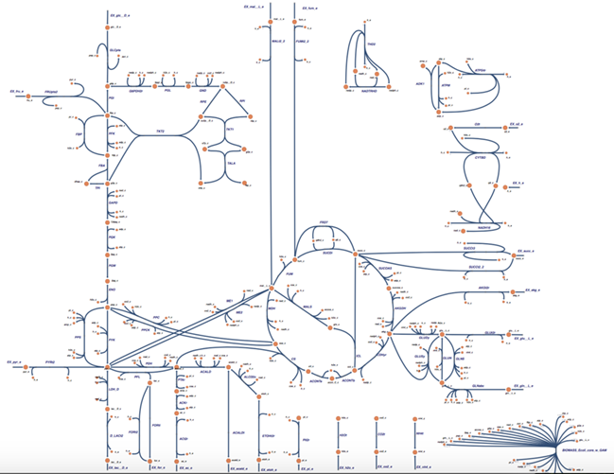In the next page, you can see the ESCHER map of the metabolic pathways of E.coli in aerobic and anaerobic conditions (Figure 2, Figure 3)

Figure 1: ESCHER map of the initial state of the metabolic pathway of E.coli

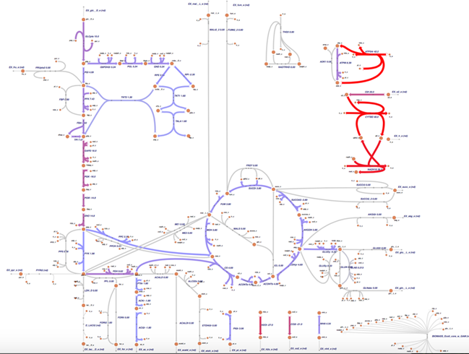

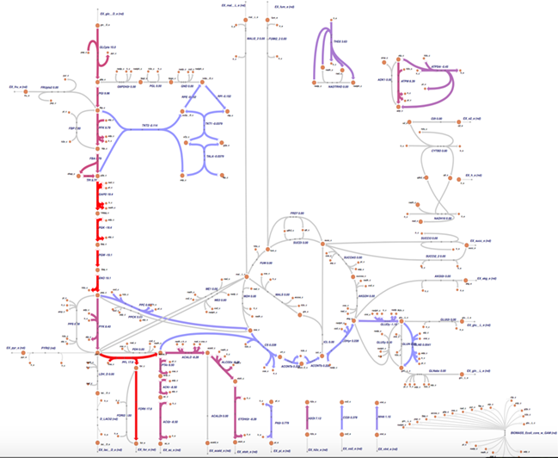

Figure 3 : Metabolic pathways of E.coli in anaerobic conditions

Figure 2: Metabolic pathways of E.coli in aerobic conditions

In aerobic condition which is illustrated in Figure 2, the glycolysis pathway and the Krebs cycle are obviously working and producing the metabolites needed for cell growth. It is important to note that the respiratory chain of E. coli is almost working at its maximum capacity. In the figure, we have shown the reduction of O2 and oxidation NADH in bright red, the same applies for the regeneration of ATP from ADP by ATP synthase. Since we have chosen the biomass reaction as objective function, the cell is trying to produce the most energy possible via ATP to reach the maximum growth rate possible.

On the other hand, in the anaerobic conditions illustrated in Figure 3, the Krebs cycle cannot be fully completed and the respiratory chain is not active. The reason is obviously absence of oxygen in this cycle. As a result in this condition, the cell relies heavily on glycolysis and fermentation to produce the energy that it requires for growing. These changes can be easily seen on Figure 3 by the red color of the reactions of the glycolysis and fermentation, which produce acetate, formate and ethanol.

1. Fill the table below and discuss about the results. What do we learn from the comparison?

Table 1 – Growth rates of E. coli based on the amount of carbon available, in aerobic and anaerobic conditions

|  |  |  |  |
| --- | --- | --- | --- |
| Substrates | Reaction ID | Max.yeild (AEROBIC) | Max.yeild (ANAEROBIC) |
| D-Glucose exchange | EX_glc(e) | 0.8326 | 0.2117 |
| D-Lactate exchange | EX_lac.D(e) | 0.3503 | 0 |
| D-Fructose exchange | EX_fru(e) | 0.8326 | 0.2117 |
| Ethanol exchange | EX_etoh(e) | 0.3304 | 0 |

The first thing that we can extract from this table is the huge difference in growth between aerobic and anaerobic conditions. E. coli grows faster in aerobic conditions, no matter what the available carbon source is. However, in aerobic conditions, there is also a big difference between different sources of carbon. As we can see in the table, glucose and fructose seem to be the most efficient carbon sources for E.coli. We can see a similar trend in the effect of different carbon sources for anaerobic growth. In anaerobic conditions, lactate and ethanol result in no growth at all, but glucose and fructose lead to growth which is lower compared to aerobic growth rates.

To summarize, this table clearly shows that E. coli is less efficient in anaerobic conditions, even with glucose or fructose as the carbon source and it performs best when it has access to enough amount of oxygen.

Part 2.Simulating gene knockouts. Comparing the number of essential genes among alternative substrates in aerobic and anaerobic conditions.

1. Identify the genes that are essential for growth in aerobic conditions and when glucose is the only carbon source. Use the singleGeneDeletion function and define as essentiality threshold 10% of the maximal growth yield. [grRatio,grRateKO,grRateWT,hasEffect,delRxns,fluxSolution] =singleGeneDeletion(model);

The answer to this part can be seen in our Matlab code for Part 2.

1. Apply the same analysis for the alternative substrates in aerobic and anaerobic conditions. You can use the script of part 1.

Similar to question 1, you can find our answer to this part in our Matlab code.

1. Fill the table below and discuss about the results. What do we learn from the comparison?

Table 2 - Number of essential genes needed to utilize different metabolites in aerobic or anaerobic conditions.

|  |  |  |  |
| --- | --- | --- | --- |
| Substrates | Reaction ID | Num.essential genes (AEROBIC) | Num.essential genes (ANAEROBIC) |
| D-Glucose exchange | EX_glc(e) | 6 | 4 |
| D-lactate exchange | EX_lac-D(e) | 16 | - |
| L-Glutamine exchange | EX_gln-L(e) | 17 | - |
| L-Glutamate exchange | EX_glu-L(e) | 9 | - |
| D-Fructose exchange | EX_fru(e) | 7 | 5 |
| Pyruvate exchange | EX_pyr(e) | 16 | - |
| Acetate exchange | EX_ac(e) | 8 | - |
| Ethanol exchange | EX_etoh(e) | 21 | - |

By comparing the number of essential genes that we need to utilize different metabolites in aerobic as well as anaerobic conditions, we learn the following:

* In general, the number of essential genes that we need in aerobic conditions is greater than those in anaerobic conditions. The reason is that aerobic respiration is a more complex process which is designed for maximal energy harvesting from carbon sources and as a result has more reactions in its pathway.
* Only two carbon sources, Glucose and Fructose, are used in anaerobic conditions (as we saw in the previous part as well) and they actually have the lowest number of essential genes in their pathways that means they have the highest flexibility.
* As we can imagine, the utilization of different carbon sources needs different essential genes as well. For example ethanol has the highest number of essential genes among other sources of carbon in aerobic conditions while glucose has the lowest number of essential genes. This proves that glucose is the best carbon source for E coli. We can conclude that E coli has evolved its metabolic pathways to be flexible in utilizing glucose for maximal exploitation.
* Some genes seem to be important in the metabolic pathway of most of our carbon sources among them we can refer to b1136 gene. These genes actually code for essential proteins such as ammonia transporters and the enzyme Isocitrate dehydrogenase.

Part 3: Understanding the FBA solution. Performing Flux Variability Analysis

1. Find the minimal and maximal flux through all the reactions in the model when optimal growth is required (the lower bound of the biomass reaction is set to 80% of the maximal growth yield and the input optPercentage is 0%, or we directly set the input optPercentage as 80%) in aerobic conditions and using glucose as the only carbon source. [minFlux,maxFlux,Vmin,Vmax] = fluxVariability(model,optPercentage)
2. Apply the same analysis in anaerobic conditions. Identify for the 5 reactions defined in the table below what is the change in the flux range.
3. Fill the table below and discuss. What can we conclude from these results?

Table 3 - Minimum and maximum fluxes through different reactions involved in glucose metabolism under aerobic and anaerobic conditions.

|  |  |  |  |  |  |
| --- | --- | --- | --- | --- | --- |
| Reactions that undergo a change | Reaction ID | Aerobic Min Flux (mmol/Gdw/h) | Aerobic Max Flux (mmol/Gdw/h) | Anaerobic Min Flux (mmol/Gdw/h) | Anaerobic Max Flux (mmol/Gdw/h) |
| Acetate exchange | EX_ac(e) | 0 | 7.5644 | 0 | 8.8029 |
| CO2 exchange | EX_co2(e) | 10.8142 | 30.2479 | -4.1246 | 17.3032 |
| D-lactate exchange | EX_lac-D(e) | 0 | 4.2903 | 0 | 10.1922 |
| aconitase (half- reaction B, Isocitrate hydro- lyase) | ACONTb | 0.7543 | 10.1285 | 0.1827 | 1.5725 |
| Malate dehydrogenase | MDH | -10.4781 | 18.7483 | -5.2737 | 1.2231 |

From the results, we can conclude:

* In general, under aerobic and anaerobic conditions, the reaction fluxes are different. Such as D-lactate exchange is amplified under anaerobic condition, CO2 exchange is attenuated.
* In the term of acetate exchange reaction, cell uses it in one pathway, but totally disregarded in anther.
* For CO2 exchange reaction, under anaerobic conditions, the minimal flux of CO2 is not 0, this indicates cell cannot disregard the reaction in another alternate pathway, namely, this reaction cannot be replaced by other alternative pathways even if the flux is attenuated, thus, the CO2 exchange reaction is an essential reaction.
* For malate dehydrogenase pathway, when the flux is attenuated, the data shows it can be reversed in alternate pathways, thus it has in alternate pathways.
* Therefore, these results indicate that the FBA solution cannot always be exclusive. The elements and pathways in the biological systems are not independent, when a pathway is blocked or attenuated, there may be alternate pathways could achieve the same goal.

Part 4: Understanding the trade-off between nutrient uptake and growth yield and other metabolic functions. Plotting the phase planes for varying nutrient and oxygen uptake rates in aerobic and anaerobic conditions.

1. First perform a robustness analysis on the effect of glucose uptake given with a maximum oxygen uptake of 20mmol/gDW/h. Plot the growth yield as a function of carbon uptake. Write a script using the functions that you learnt in the previous parts.



Figure 4 - Robustness Analysis for Glucose

The trade-off between carbon uptake and growth yield can be seen in the Figure4. The system’s growth rate stays 0 hr-1 until the glucose uptake rate increase to approximately 3 mmol gDW-1 hr-1, which is necessary to meet the lower bound in the ATP maintenance reaction though taking glucose. The growth rate keeps rapidly continues increase with increasing uptake glucose rate until reaching 8 mmol gDW-1 hr-1, after that the growth rate slows down. Because the oxygen required to oxidase the glucose becomes the limiting reactant. Generally, Figure 4 shows the relationship between glucose uptake rate and growth rate of the system.

1. To plot the phenotypic phase plane, calculate the maximal growth yield for a range of oxygen and glucose uptake rate between 0 and 30 mmol/gDW/h. Plot a 3-D plane (function: surfl) to identify the effect on the growth yield. Write a script using the functions that you learnt in the previous parts.



Figure 5 - Phenotypic Phase Plane for Glucose.

Figure 5 also shows the relationship between glucose uptake rate and growth rate of the system, and shows more clearly about the different phases, but lack the information about the slope of each phase, the detailed number of rate is difficult to identify compared with Figure 4. In order to know the shadow prices with respect of glucose, Figure 6 is introduced to identify these prices.



Figure 6 - Shadow Prices for Glucose. The different phases are indicated with a color and number.

1. Determine the shadow prices with respect to glucose uptake for the different metabolic phenotypes you observe in the phase plane. Which phenotypes are the most sensitive to a variation in carbon uptake? Find the differences of the flux distribution between the metabolic phenotypes you observe in the phase planes. (Hint: Use ESCHER maps to visualize the flux profiles)

Table 4 - Shadow Prices with respect to Glucose in the system

|  |  |
| --- | --- |
| Phenotypic Phase | Shadow Price |
| 1 | 0 |
| 2 | -0.0229 |
| 3 | 0.0230 |
| 4 | 0.0325 |
| 5 | 0.0360 |

Table 4 shows the shadow prices with respect to glucose uptake for the different metabolic phenotypes. For the phase 1, the shadow price is 0 due to insufficient glucose to reach the ATP maintenance requirement. At the phase 2, the shadow price is -0.0229, because in this stage, oxygen becomes the limiting bound, there is insufficient glucose to reduce the oxygen. The phase 3, the shadow price is 0.0230, in this stage, the excess of glucose generates the formation of acetate (EX_ac_e(nd)) due to the lack of oxygen in the system to fully oxidize the glucose. Phase 4’s price is 0.0325, phase 5 is 0.0360, in these two stages, where the excess of glucose leads to the secretation of acetate (EX_ac_e(nd)) and formate (EX_for_e(nd)) and EX_ac_e(nd)), formate (EX_for_e(nd)) and ethanol (EX_etoh_e(nd)) respectively for each stage.

The most sensitive phenotype is phase 5 (Figure 6), where the shadow price is at 0.360, which is the highest growth rate under the same glucose uptake rate, and occur with low presence of oxygen and excess levels of glucose in the system. At phase 6, excess of glucose leads to the formation of various fermented products.

1. Repeat the three analysis with succinate as the only carbon source, and then with pyruvate.

Figure 7 - The pyruvate is single analyte. The left graph shows the robustness analysis of Pyruvate. The middle graph shows the Phenotypic Phase Plane of the pyruvate. The right graph indicates the 2D representation of the shadow prices for the uptake of pyruvate.



Figure 8 - The succinate is single analyte. The left graph shows the robustness analysis of Succinate. The middle graph shows the Phenotypic Phase Plane of the succinate. The right graph indicates the 2D representation of the shadow prices for the uptake of succinate.

1. Compare the curves and the phase planes. What can we learn from these results? What is the nutrient to which biomass is the most sensitive? What are the optimal conditions for growth?

When pyruvate is the single analyte, 4 phases are identified, the shadow prices are shown in the Table 5. At the phase 1, the shadow price is 0 due to insufficient pyruvate to reach the ATP maintenance requirement. At the phase 2, the shadow price is -0.0229, because in this stage, oxygen becomes the limiting bound, there is insufficient pyruvate to reduce the oxygen. The phase 3, the shadow price is 0.0220, in this stage, the excess of pyruvate generates the formation of acetate (EX_acc_e(nd)) due to the lack of oxygen in the system to fully oxidize the glucose. Phase 4’s price is 0.0297, where the excess of glucose leads to the secretation of acetate (EX_acc_e(nd)) and formate (EX_for_e(nd)).

Table 5 - Shadow Prices with respect to Pyruvate in the system

|  |  |
| --- | --- |
| Phenotypic Phase | Shadow Price |
| 1 | 0 |
| 2 | -0.0229 |
| 3 | 0.0220 |
| 4 | 0.0297 |

When succinate is the single analyte, 5 phases are identified. The shadow prices are shown in the Table 6. At the phase 1, the shadow price is 0 due to insufficient succinate to reach the ATP maintenance requirement. At the phase 2, the shadow price is -0.0229, which is limited by the oxygen uptake and a series of posterior phases (phases 3, 4 and 5) where the lack of oxygen to oxidize the carbon base, leads to the formation of fermented products including acetate, formate and ethanol.

Table 6 - Shadow Prices with respect to succinate in the system

|  |  |
| --- | --- |
| Phenotypic Phase | Shadow Price |
| 1 | 0 |
| 2 | -0.0229 |
| 3 | 0.0227 |
| 4 | 0.0366 |
| 5 | 0.0407 |

Succiante is the most sensitive carbon base, due to the highest shadow price of 0.0407 at Phase 5, which is the phase under deprivation conditions. Because biomass production is proportional to the growth rate of the system, thus, the highest shadow price indicates the most sensitive production of biomass. We can observe that all the carbon bases including glucose, pyruvate and Succiante, the phase 2 is the same at -0.0229, phase 2 is the oxygen limited phase.

The optimal conditions for growth is the optimal conditions that allow the system uptakes both oxygen and carbon base. The optimal conditions can be only occur in the phases which are oxygen limited phase (phase 2) and the phases that leads to generate fermented products (phase 3-4 in pyruvate, or phase 3-5 in glucose and succinate). Thus, the optimal condition will occur in the edge between phase 2 and phase 3. The optimal condition for each carbon bases is shown in the Table 7, which is a liner equation.

Table 7 - Linear approximation of the optimal conditions for each of the carbon bases

|  |  |
| --- | --- |
| Carbon Base | Line of Optimality |
| Glucose | EX_o2_e = 1.8455(EX_glc_e) + 2.1204 for (EX_glc_e) > 1 |
| Pyruvate | EX_o2_e = 1.0282(EX_pyr_e) + 2.7621 for (EX_pyr_e) > 2 |
| Succinate | EX_o2_e = 1.4558 (EX_succ_e) + 3.0328 for (EX_succ_e) > 2 |